Holiday Movies Crossword

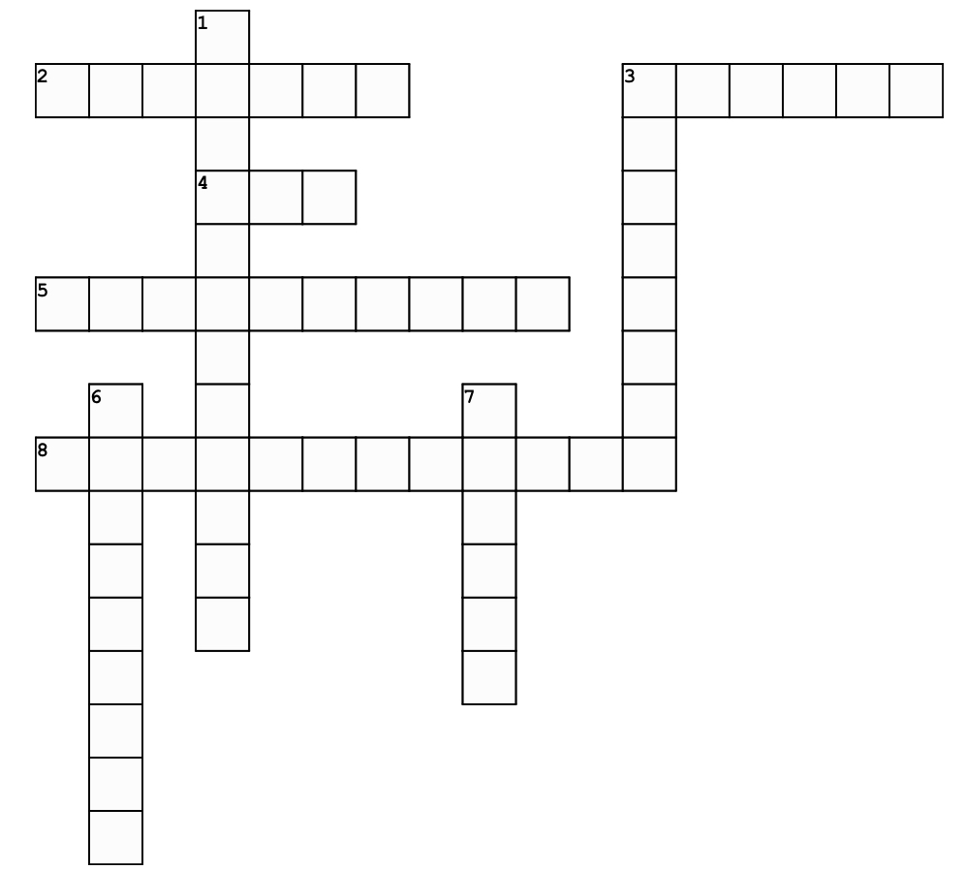

**Across**

2. This reindeer is celebrated in a popular song and a 1964 film.

3. Based on the story by Dr. Seuss, this character plots a way to ruin Christmas.

4. A comedy starring Will Ferrell about a man named Buddy.

5. Often seen as a ballet, many different adaptions have been made of this classic story.

8. Children find holiday magic on a train in this family movie.

**Down**

1. This rom-com follows nine love stories in England during the holiday season.

3. Small furry creatures wreck havoc on a small town in this 1984 film.

6. A 1990 movie about a boy named Kevin, who finds himself deserted by his family.

7. A famous snowman, who’s known for having a “corn cob pipe and a button nose” in a 1969 movie.